# Report 4

This report includes updates and progress report for Task 1. I could not attend to Task 2 this week.

## Scope

|  |  |  |
| --- | --- | --- |
| **Tasks:** | **Task Goal/ Desired outcome** | **Progress** |
| Task 1 | **PCR data management**  Extracting the data in (.csv) from original PCR results file(.eds) | Quant-Studio 5: Completed |
| Quant-Studio 7: Completed |
| Other instruments: On-hold |
| Task 2 | **GS-Call data work-flow**  *Goal:*  This task aims to put the PCR result data into a proper format for further analysis in GS-Call software.  *Desired outcome:*  The application should open up in the web browser and take the user input info, then generate a specific formatted (.csv) file containing the information of samples/targets to be imported on the PCR machine by the user. | 1. Developing the code: 75% done 2. Interactive plate map was added (developing) 3. Working on panel design |
| 1. Deploying the app |
| 1. Developing a data base in SQL and connecting that to the app |
| 1. Deploying the app with SQL database |
| :D more challenges to come |

## Task 2 (*GS-Call data flow)* progress:

We are working on GSL_Experiment_Setup web application to generate the layout information for PCR experiment.

***What the algorithm does:***

The algorithm works based on the data (panels: targets vs filters) for each “kit/product” and the given samples names list/number. Then, assuming a predefined layout of master mixes/ sample location through 384 well plate (according to Figure 2 & 3), generates the csv file including the info for all wells (a sample is attached to the email).

*New feature:

As suggested by Angela, an interactive plate-map is added to the body of the app. In this way, R&D scientist have the option to assign different kits/assays to different sub-blocks of 384 well plate.

I am currently working to develop this feature

An screen shot of the web app is shown in Figure 1. There are 3 very simple steps for the users to follow:

1. The user follows the left sidebar and first selects the kit/product that they want to use and the panels of the kit will be shown for them in the right-hand side.
2. Next, the user copies or writes the name of the samples for the kit (the max sample number
3. The user will assign different kits in blocks within the same plate map.

***Challenges to be addressed:***

1. R&D may want to test several kits per plate 🡪 interactive platemap has been added
2. There are 2 more working layout for master mixes/samples 🡪 will be addressed in the second place

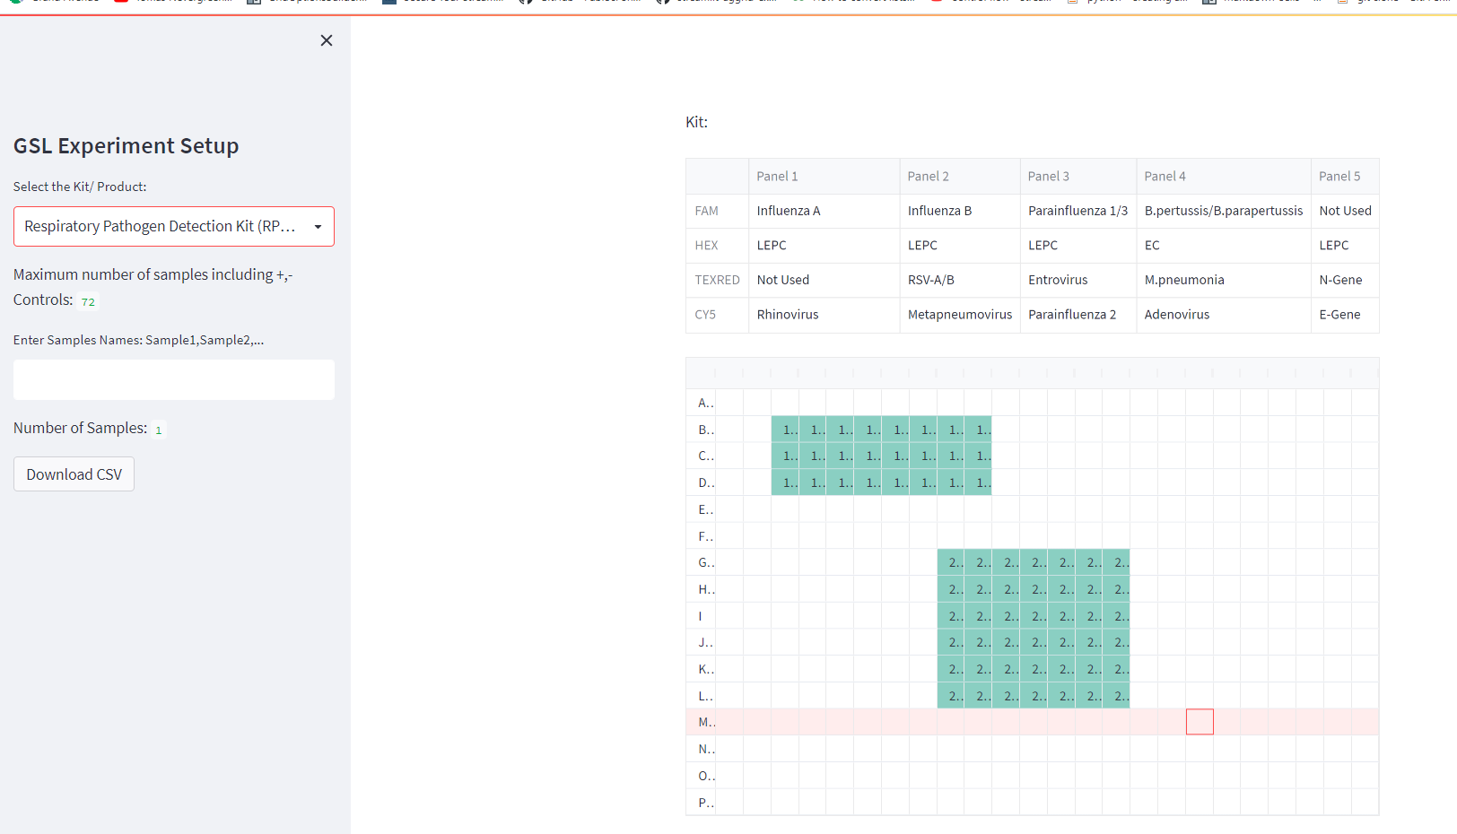

1

2

3

Figure 1: GSL-Experiment_setup with interactive platemap feature

|  |  |  |  |  |  |  |  |  |  |  |  |  |  |  |  |  |  |  |  |  |  |  |  |  |
| --- | --- | --- | --- | --- | --- | --- | --- | --- | --- | --- | --- | --- | --- | --- | --- | --- | --- | --- | --- | --- | --- | --- | --- | --- |
|  | 1 | 2 | 3 | 4 | 5 | 6 | 7 | 8 | 9 | 10 | 11 | 12 | 13 | 14 | 15 | 16 | 17 | 18 | 19 | 20 | 21 | 22 | 23 | 24 |
| A | M | a | s | t | e | r | M | i | x | 1 |  |  |  |  |  |  |  |  |  |  |  |  |  |  |
| B | M | a | s | t | e | r | M | i | x | 2 |  |  |  |  |  |  |  |  |  |  |  |  |  |  |
| C | M | a | s | t | e | r | M | i | x | 3 |  |  |  |  |  |  |  |  |  |  |  |  |  |  |
| D | M | a | s | t | e | r | M | i | x | 4 |  |  |  |  |  |  |  |  |  |  |  |  |  |  |
| E | M | a | s | t | e | r | M | i | x | 5 |  |  |  |  |  |  |  |  |  |  |  |  |  |  |
| F |  |  |  |  |  |  |  |  |  |  |  |  |  |  |  |  |  |  |  |  |  |  |  |  |
| G |  |  |  |  |  |  |  |  |  |  |  |  |  |  |  |  |  |  |  |  |  |  |  |  |
| H |  |  |  |  |  |  |  |  |  |  |  |  |  |  |  |  |  |  |  |  |  |  |  |  |
| I |  |  |  |  |  |  |  |  |  |  |  |  |  |  |  |  |  |  |  |  |  |  |  |  |
| J |  |  |  |  |  |  |  |  |  |  |  |  |  |  |  |  |  |  |  |  |  |  |  |  |
| K |  |  |  |  |  |  |  |  |  |  |  |  |  |  |  |  |  |  |  |  |  |  |  |  |
| L |  |  |  |  |  |  |  |  |  |  |  |  |  |  |  |  |  |  |  |  |  |  |  |  |
| M |  |  |  |  |  |  |  |  |  |  |  |  |  |  |  |  |  |  |  |  |  |  |  |  |
| N |  |  |  |  |  |  |  |  |  |  |  |  |  |  |  |  |  |  |  |  |  |  |  |  |
| O |  |  |  |  |  |  |  |  |  |  |  |  |  |  |  |  |  |  |  |  |  |  |  |  |
| P |  |  |  |  |  |  |  |  |  |  |  |  |  |  |  |  |  |  |  |  |  |  |  |  |

**Figure 2: Master mixes dispense horizontally through the rows of 384 well plate (Can handle up to 15 master mixes that is (16 rows except the last row=15) in use). The schematic shows the layout of master mixes for a kit with 5 panels/master mixes.**

|  |  |  |  |  |  |  |  |  |  |  |  |  |  |  |  |  |  |  |  |  |  |  |  |  |
| --- | --- | --- | --- | --- | --- | --- | --- | --- | --- | --- | --- | --- | --- | --- | --- | --- | --- | --- | --- | --- | --- | --- | --- | --- |
|  | 1 | 2 | 3 | 4 | 5 | 6 | 7 | 8 | 9 | 10 | 11 | 12 | 13 | 14 | 15 | 16 | 17 | 18 | 19 | 20 | 21 | 22 | 23 | 24 |
| A | N | 3 |  |  |  |  |  |  |  |  |  |  |  |  |  |  |  |  |  |  |  |  |  | 70 |
| B | N | 3 |  |  |  |  |  |  |  |  |  |  |  |  |  |  |  |  |  |  |  |  |  | 70 |
| C | N | 3 |  |  |  |  |  |  |  |  |  |  |  |  |  |  |  |  |  |  |  |  |  | 70 |
| D | N | 3 |  |  |  |  |  |  |  |  |  |  |  |  |  |  |  |  |  |  |  |  |  | 70 |
| E | N | 3 |  |  |  |  |  |  |  |  |  |  |  |  |  |  |  |  |  |  |  |  |  | 70 |
| F | 1 | 4 |  |  |  |  |  |  |  |  |  |  |  |  |  |  |  |  |  |  |  |  |  | 71 |
| G | 1 | 4 |  |  |  |  |  |  |  |  |  |  |  |  |  |  |  |  |  |  |  |  |  | 71 |
| H | 1 | 4 |  |  |  |  |  |  |  |  |  |  |  |  |  |  |  |  |  |  |  |  |  | 71 |
| I | 1 | 4 |  |  |  |  |  |  |  |  |  |  |  |  |  |  |  |  |  |  |  |  |  | 71 |
| J | 1 | 4 |  |  |  |  |  |  |  |  |  |  |  |  |  |  |  |  |  |  |  |  |  | 71 |
| K | 2 | 5 |  |  |  |  |  |  |  |  |  |  |  |  |  |  |  |  |  |  |  |  |  | P |
| L | 2 | 5 |  |  |  |  |  |  |  |  |  |  |  |  |  |  |  |  |  |  |  |  |  | P |
| M | 2 | 5 |  |  |  |  |  |  |  |  |  |  |  |  |  |  |  |  |  |  |  |  |  | P |
| N | 2 | 5 |  |  |  |  |  |  |  |  |  |  |  |  |  |  |  |  |  |  |  |  |  | P |
| O | 2 | 5 |  |  |  |  |  |  |  |  |  |  |  |  |  |  |  |  |  |  |  |  |  | P |
| P |  |  |  |  |  |  |  |  |  |  |  |  |  |  |  |  |  |  |  |  |  |  |  |  |

**Figure 3: Samples are located vertically through the columns of 384 well plate (Can handle up to 72 samples for a kit with 5 panels (3 sample per column X 24 columns =72) in use including N negative control and P positive control). The schematic shows the layout of sample location for a kit with 5 panels/master mixes.**